Device Requirements
Windows  Tablet/Laptop | 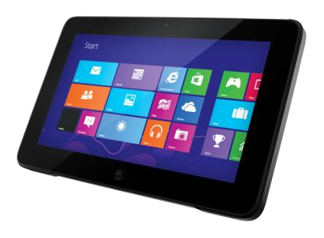 | Minimum 10 inch screen  Please check the device has a camera as it is used extensively for tasks.  A number of our current Stage 3 students have an external mouse to use with the tablet. This offers flexibility with how the device is used. You might like to consider purchasing one. Most come with a keyboard. Touchscreen is very highly recommended.
Operating System | 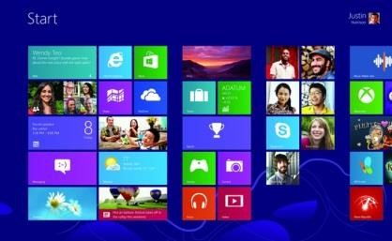 | Windows 10 or 11
Stylus | 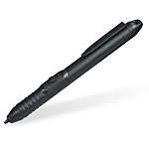 | Highly recommended but not essential.
Software | 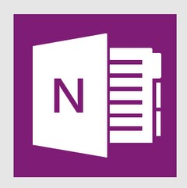 | Most devices will come with Microsoft Office – however please do not purchase it separately as you are able to access it free via our school account with Office365.
Folio (case) | 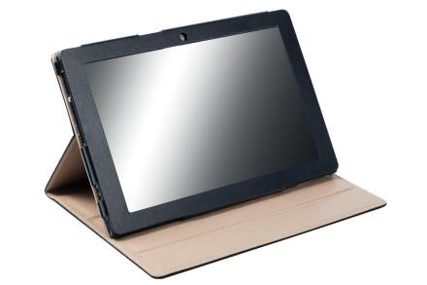 | Students need to take care of their equipment. School bags will potentially  become lighter due to the reduction of  physical books but extra care is essential to ensure that the tablet remains in good working order.

Extended Warranty | Most devices come with a one year warranty. It is highly recommended that you seek extended warranties with your supplier.

School Vision: “To Bring Christ and His message, in all its richness, into the hearts and lives of all”

